PROLAM PuR undercoat:
test result on the field
Exposed two years to direct outside conditions

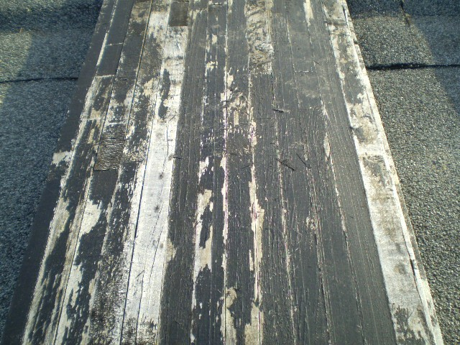

Water base undercoat

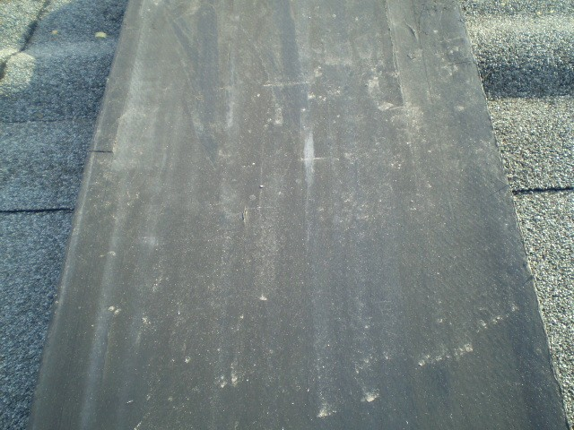

PROLAM PuR undercoat

